# **Responsive Landing Page**

This repository contains a simple, responsive landing page built using HTML and CSS.

## **Features**

* Modern header with logo and navigation links
* Centered hero section with heading, description, and a call-to-action button
* Styled footer with social links and copyright information
* Responsive design using CSS Flexbox and media queries to adapt for mobile and desktop

## **How to Use**

1. Open index.html in your web browser directly or use VS Code Live Server for live preview.
2. Resize the window or open on different devices to see the responsive behavior.

## **Screenshot**

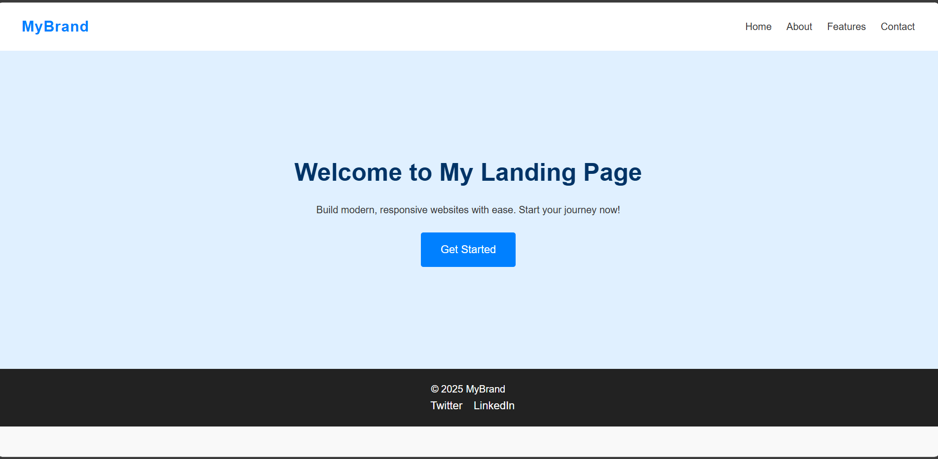

## **Technology Used**

* HTML5
* CSS3 (Flexbox and Media Queries)

## **Author**

* Name : Hithashree B
* Gmail : hithashreebanadka@gmail.com